Competitive Shooters of Lake Norman USPSA April 9th, 2026
COURSE DESIGNER: Rocky Perillo

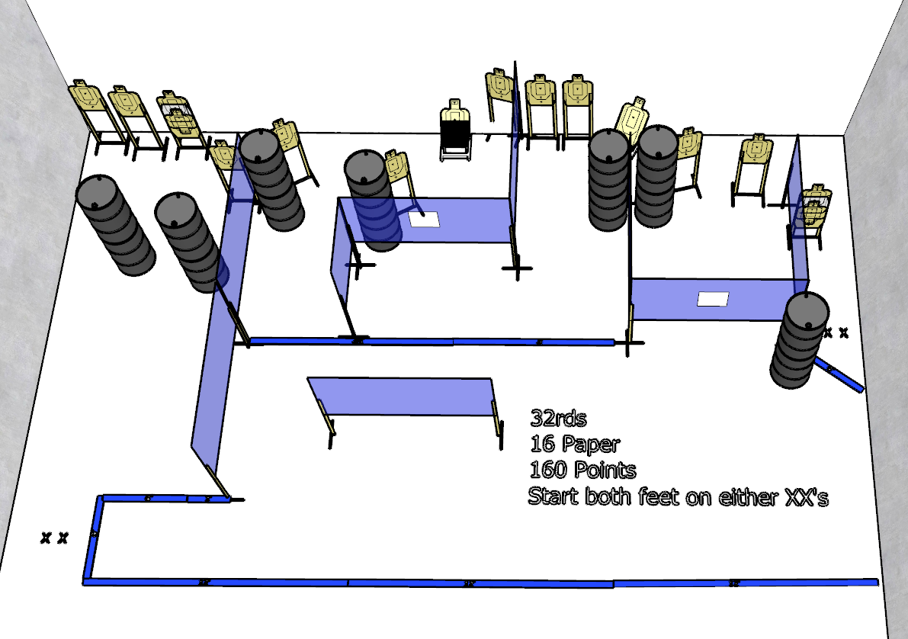

Stage 1 – What’s your name?
32 rounds, 160 points, Comstock
There are 16 cardboard targets.
Starting with both feet on either XXs.
Handgun is unloaded and holstered, wrists below belt.
PCC is unloaded, held in both hands, stock touching belt.
On the audible start signal, engage targets from within the shooting area.

